**DB Setup**

1. Create Schema called “gerrys”
2. Select the schema “gerrys” from the left hand pane, when its selected the font becomes bold
3. Select lines 2-6 to drop the tables
4. 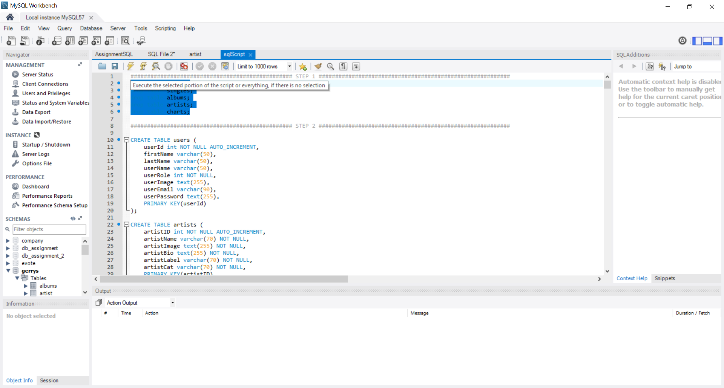
5. Click execute to drop tables. (If you haven’t already created the tables previously then there’s no need for this step)

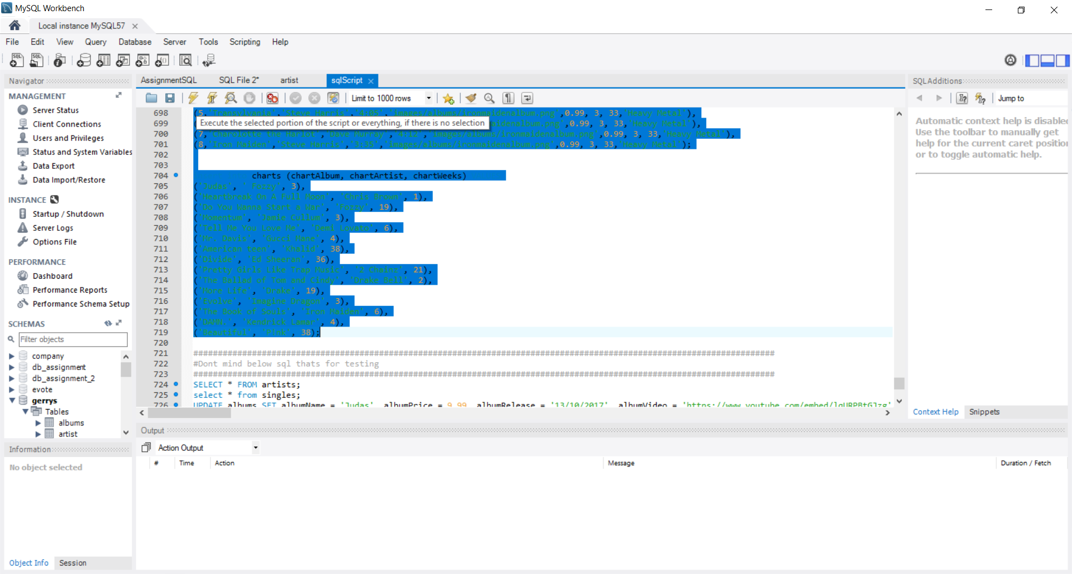

1. Select from line 10 to 719 and click execute the same as above.